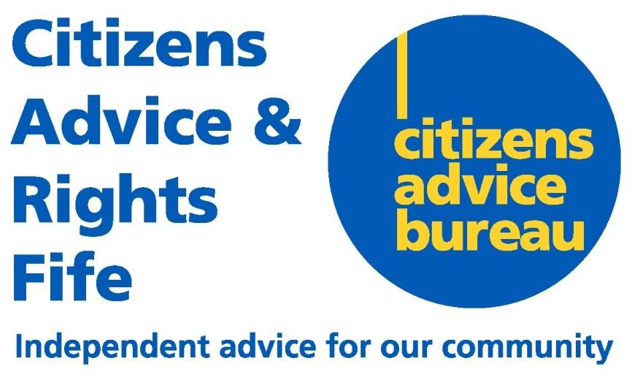

Fair Work First Statement

CARF recognises that a workforce where staff are offered an effective voice, opportunity, security, fulfilment and respect is a workforce which is best placed to achieve CARF’s vision of “a better life for the people of Fife”.

To this end, CARF is committed to the Fair Work First criteria, specifically:

We have an appropriate channel for effective employee voice

- We involve our recognised trade unions in key governance and decision-making structures through the Joint Consultative Committee.
- We recognise trade unions across all employee groups for the purpose of collective bargaining and encourage membership.
- We provide facility time to support regular engagement between our trade unions and their members.
- We make available to trade union representatives, wherever possible, reasonable facilities necessary for them to carry out their duties efficiently and communicate effectively with their members.
- We engage in constructive dialogue with our employees and their trade union representatives to address workplace issues and disputes.
- Employees are offered supportive contact with their line manager.
- We have measures in place to support employees in the workplace and have zero tolerance of bullying and other forms of abuse or harassment.

We invest in workforce development

- We provide learning opportunities for employees at all levels of the organisation
- Formal and informal training is offered and encouraged across the workforce, relating to specific roles as well as wider development.
- We provide training for employees to become Mental Health First Aiders who can offer a confidential listening ear to other employees in times of vulnerability.
- We regularly seek out the views and experiences of our employees on employment and related matters to be a more responsive and supportive employer.

We do not use zero-hour contracts inappropriately

- We do not use zero-hour contracts within CARF.

We take action to tackle the gender pay gap and create a more diverse and inclusive workplace

- We support flexible working across the organisation offering wide range of flexible working patterns
- We offer all employees the opportunity to adopt a blended workstyle, a blend of working from home and working from CARF’s Head Office.
- We are a Carer Positive employer showing our commitment to a working environment where carers are valued and supported.
- We make reasonable adjustments for employees with a disability or who have a short or long term impairment that could affect their ability to work.
- If an employee receives a short time frame terminal diagnosis, we will work with them to consider how we manage an appropriate outcome.

We commit to paying the Real Living Wage

- We are an accredited Living Wage employer
- We support the initiative for Fife to become a Living Wage region

We offer flexible and family-friendly working practices for all employees from day one of employment

These include:

- Time off for dependents
- Part-time working arrangements
- Parental Leave
- Neonatal Leave
- Parental Bereavement Leave
- Compassionate and other Special Leave
- Time off for voluntary and other public duties

We oppose the use of fire and rehire practice

- We only consider effecting change where there is a legitimate business need
- We strive to achieve change through agreement
- We are committed to working with our trade union partners to ensure there is affective consultation and negotiation relating to change.

Our Fair Work First Statement will remain under review and open to further improvement in consultation with our people and their formal representatives.

